Valentine Dinner
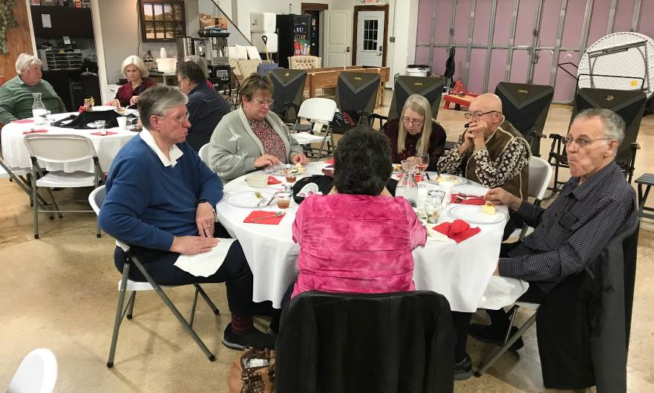

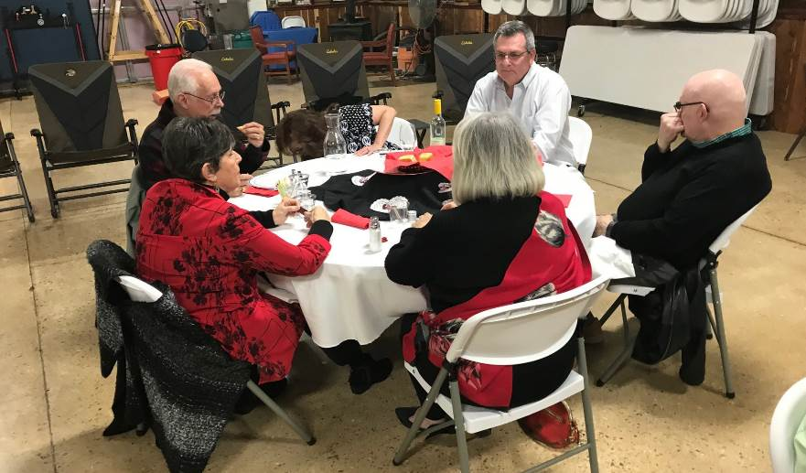

Valentine Dinner
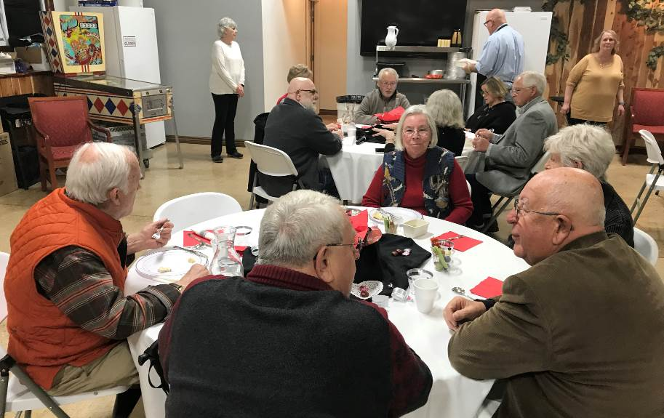

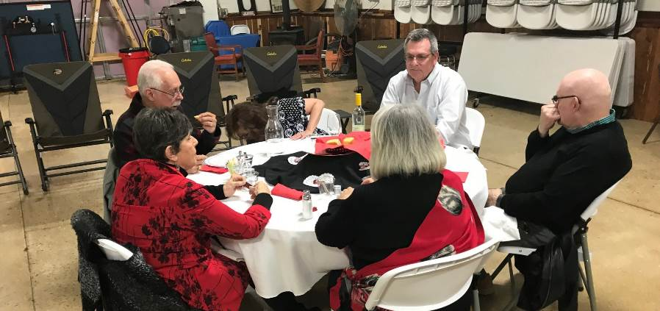

 |  |  | 1  Lenten Service 5:00pm | 2  Bible Study 2:00pm | 3 | 4
5 Second Sunday in Lent  Worship with. Communion –9:30am  Adult Bible study – 11:00am | 6 | 7 | 8  Lenten Service 5:00pm | 9  Bible Study 2:00pm | 10 | 11  Set your clocks ahead one hour
12 Third Sunday in Lent  Worship with Communion – 9:30am  Adult Bible study – 11:00am | 13  Men’s Fellowship  – 8:30am | 14  Elders - 8:00am  Council - 9:00am | 15  Lenten Service 5:00pm | 16  Bible Study 2:00pm | 17 | 18
19 Fourth Sunday in Lent  Worship with Communion – 9:30am  Adult Bible study – 11:00am | 20 | 21  Circuit Conference  Bella Vista  Ladies Guild  10:00am social  11:00am meeting | 22  Lenten Service 5:00pm | 23  Bible Study 2:00pm | 24 | 25
26 Fifth Sunday in Lent  Worship with Communion – 9:30am  Adult Bible study – 11:00am | 27 | 28 | 29  Lenten Service 5:00pm | 30  Bible Study 2:00pm | 31
Grace Lutheran Church March 2023 Holiday Island, Arkansas

Sunday Monday Tuesday Wednesday Thursday Friday Saturday

